# Assembling the Aegis Handheld

## Step 1: Install the wires to the Joysticks

Find the connectors that are used to connect to the joysticks. Cut off the connectors that do not connect to the joystick side. Then solder the wires to the underside of the circuit board on the left- and right-hand side. To figure out the ordering of the wires follow these steps and refer to Figures 1 and 2:

1. Put the circuit board down on a table face up.
2. Insert the connectors into the joysticks with the one side cut off.
3. Put the joysticks upside down on the left- and right-hand side of the board making sure the connectors face towards the circuit board. The joysticks are upside down because that is how they are oriented in the case relative to the circuit board.
4. Align the wires so that the top wire goes to the top pad, the second wire goes to the second pad from the top, and so on and so forth. When the wires are aligned correctly the wires should go straight from the joysticks to the circuit board with no wires crossing.
5. Mark the wires so that you know which wires go to which pad, then turn over the circuit board and joysticks keeping their alignment. Connect the joystick wires to the corresponding pads using a soldering iron. The joysticks can be disconnected before the wires are soldered to make it easier if desired, just don’t lose track of which wire gets connected to which pad.

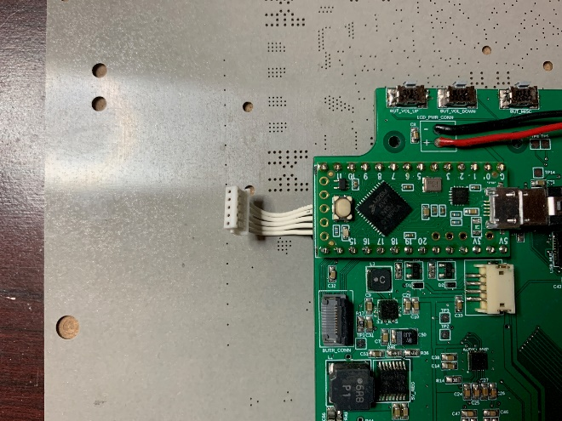 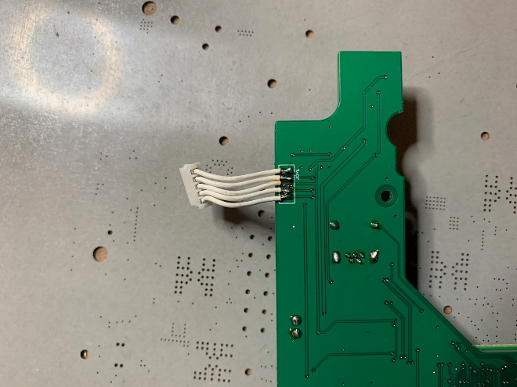

Figure 1: Joystick Wires Top Figure 2: Joystick Wires Bottom

## Step 2: Install the screen

Start by test fitting the screen to see how well it fits. When inserting the screen make sure the ribbon cables should be at the bottom side of the handheld. The screen should fit flush with the front surface of the handheld without pushing the inner structure at all. If the screen doesn’t fit flush, then use either sandpaper or an X-acto knife to trim down any areas that are needed. This includes edges where the glass sits and the screw mounts. Depending on how the case was printed these areas may need to be trimmed down so that the screen fits correctly. Once the screen fits correctly then add some double-sided tape to the back side of the screen and secure the screen to the case using the tape and the 3M screws. Follow this with some Kapton tape over the screws (as shown in Figure 3) to prevent shorting to the circuit board if the screws touch the board.


Figure 1: Kapton Tape Covering Screen Screws

Figure 3: Screen Screws Covered in Kapton Tape

## Step 3: Install the Speaker/Rumble Motors

Place the main circuit board in the case lining it up with the screw holes but don’t screw it down yet. Place the rumble motors in their locations on the left- and right-hand sides with the axles pointing towards the outside of the case. Take one of the wire sets listed as the Speaker/Motor Jumper in the BOM. Using the wires measure the distance from the motor connector on the PCB to the connections on the motors. Make sure the wire is routed down first and then separates at the bottom. Cut the wires to the appropriate length; then using wire strippers and a soldering iron attach the wires to the motors. Make sure that the two left wires go to the left motor and the two right wires go to the right motor. Other than that, it doesn’t matter which wire connects to the +/- terminals of the motor as it doesn’t matter which direction the motor rotates for the rumble feature.

Do the exact same steps with the speakers except it would be better if the same wire of each pair goes to the same terminal on the speaker. This will keep the speakers in sync with each other better. However, this is not required, and you probably won’t notice a difference in the audio.

Once this is complete screw down the speakers and then glue the rumble motors in place. Remove the main circuit board and then route the wires through the path you determined earlier. The route of the wires should go beneath the circuit board to keep it clean, but this is not required. Figures 4 and 5 show an example of the speakers and motors with wires cut to length.

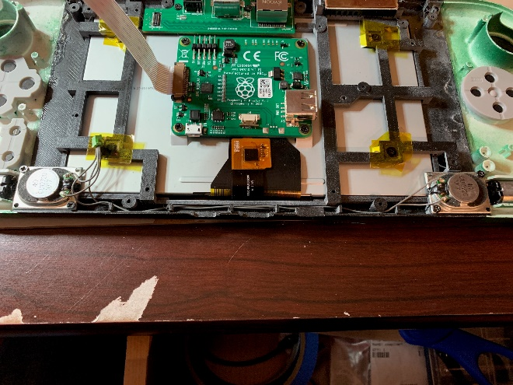 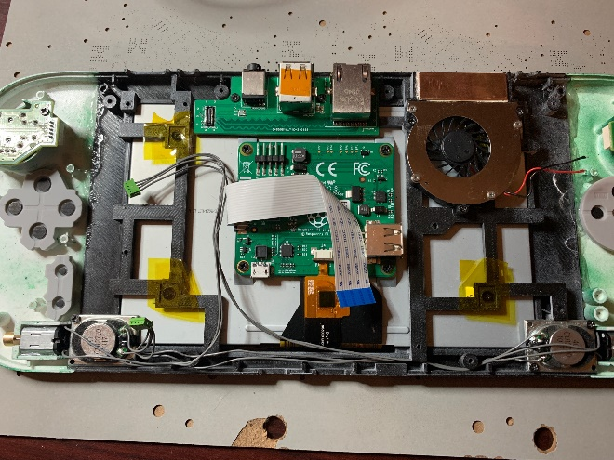

Figure 4: Speaker Placement and Wires Cut to Length Figure 5: Motor Placement and Wires Cut to Length

## Step 4: Install the Circuit Boards

Before installing the circuit boards, you will need to insert the flat ribbon cable into the official raspberry pi screen display board (as seen in both Figures 4 and 5). You then need to fold over the cable to the right so that it doesn’t get stuck under the main circuit board once it is installed. If you don’t do this first it is very difficult to insert this cable later.

Install the USB/Ethernet circuit board at the top of the case and secure it down with 2M x 3mm screws. The top ports (headphone jack, USB ports, and ethernet ports) should all line up with their corresponding hole in the case as shown in Figure 6.

USB/Ethernet Circuit Board


Figure 6: USB/Ethernet Circuit Board

Install the main circuit board lining up the board with the screw holes again using 2M x 3mm screws. The connectors on the bottom should also line up with the holes in the case. Watch out for the mezzanine connector that connects the two circuit boards together. They should line up perfectly if both circuit boards line up with their screw holes. DO NOT force them together if they are not lining up correctly, you run the risk of damaging the connectors between the boards. Instead try loosening all the screws and to get the boards connected then tighten the screws down. Once it is screwed down connect the speakers and rumble motors. While it can be done later, now would also be a good time to install the raspberry pi if you have not done so already. Refer to Figure 7 for the installed circuit board.

Main Circuit Board


Figure 7: Main Circuit Board

## Step 5: Connect the Screen

Connect the display board ribbon cable that you folded over previously. There should be two folds in the cable once connected as shown in Figure 7 above.

Follow this by connecting the 5V power and ground to the connector at the top of the display board. This can be done by taking the Red and Black wires that come with the screen and plugging them into the screens display board. The power and ground connections should be clearly labeled (don’t mix this up as it can destroy the display board and you will need to buy a whole new screen). Then route them to the connecting on the main circuit board in the upper left. Cut them to the appropriate length and then solder them to the board using a soldering iron. The power connection should be connected to the hole with the “+” next to it and the ground connection should be connected to the hole with the “-“ next to it.

## Step 6: Insert the joysticks and controller buttons

Install the joysticks making sure that the white connectors face towards the center of the device. They should fall into place with the tabs and the screw holes. Use the 2M x 4mm screws to attach the joysticks as shown in Figure 8. Do this for both sides.

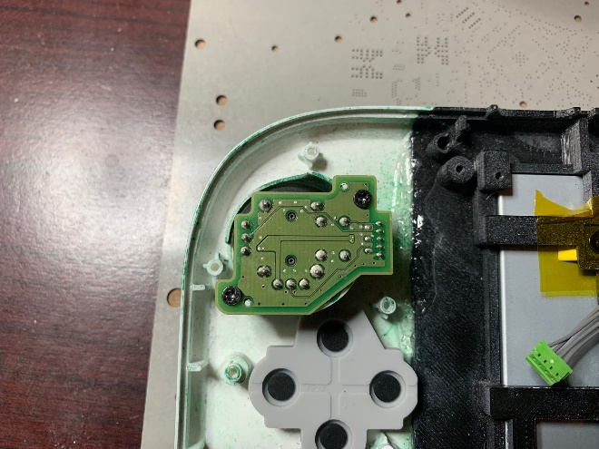

Figure 8: Joystick Installed

Add the face buttons into their corresponding places. They should align to the keying elements that were built into the case and the buttons. Then cover the buttons with the conductive rubber. If the rubber does not fit, then the rubber can be slightly cut to make sure it does. However, the black conductive part should not be tampered with as it would affect how well the buttons work. No cutting should be needed unless modifications were made to the case beyond what was offered in the repository. See Figures 9 and 10 for how this should look when installed. Do the same for the other side.

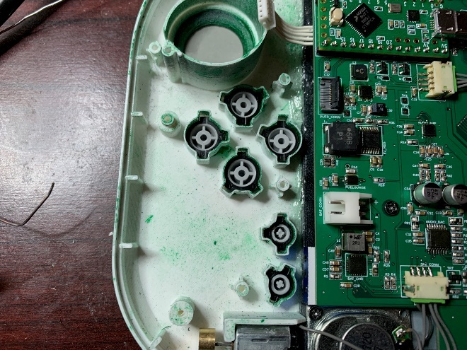 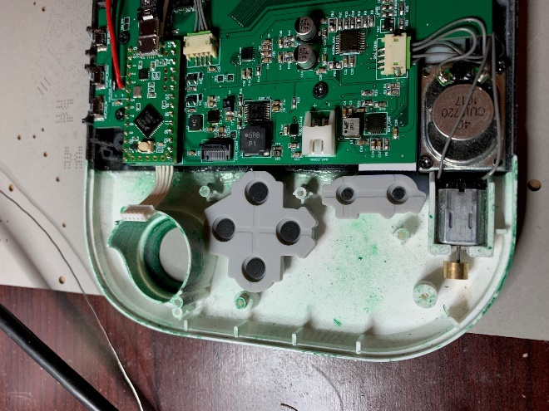

Figure 9: Face Buttons Figure 10: Conductive Rubber over Buttons

Proceed by connecting the joystick wires from the main circuit board to the joysticks on both sides. They should go in the connectors without any twisting of the wires. If twisting is required, then re-examine the soldering order of the wires referring to step 1. See Figure 11 for the connected joystick wires.

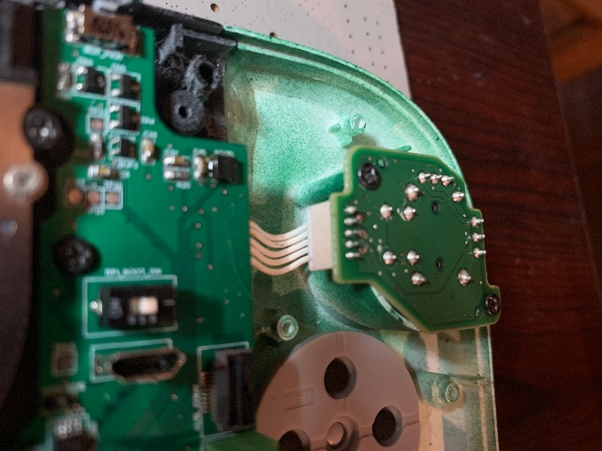

Figure 11: Joysticks with Wires

After the buttons, conductive rubber, and joysticks have been installed then the white Wii U button sub-assemblies can be installed using 2M x 4mm screws as shown in Figure 12. You may have to remove the conductive rubber for the shoulder buttons to screw in the top screws. If so, then make sure to remember to put the conductive rubber back once the screws are in place.

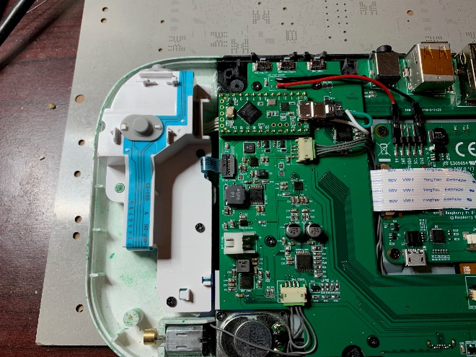

Figure 12: Wii U Button Sub-Assemblies

Once the Wii U Button Sub-Assemblies are in place then connect the flexible connecting strip to the main circuit board on both sides. They should fit in without difficulty and the connector should clamp down on it preventing it from becoming lose. Make sure the flexible connecting strip is all the way into the connector to assure a good connection.

## Step 7: Install Heatsink, Fan, Optional Antenna, and Heat Pipe

First install the heatsinks and the copper piece as shown in Figure 13. It is recommended that the heat sinks be glued down using CA glue but heat resistant tape may also be used if that is available. Heat resistant tape must be used if using tape as the heatsink will get warm and the tape will lose its adhesion. After attaching the heatsinks, use heat transfer tape on top of them and then place a copper piece that fits the same size. I recommend measuring the heat sink area after they are attached to the case. In Figure 13 the white visible layer between the heatsinks and the copper is the heat transfer tape.

Figure 3: Heat Sinks and Copper Installed

After the heat sink/copper are installed then install the fan right below it, making sure that the screw holes line up correctly. See this in Figure 14. Once it is secure then place the red/black wires into the fan connector on the Main Circuit Board. The red wire should go into the side marked with “+” and the black wire goes into the side marked “-“. Make sure to tighten down the terminal heads once the wires are in place.

Figure 14: Fan Installation Figure 15: Heat Pipe

Now that the fan is installed the heat pipe may be placed over the raspberry pi CPU and the copper connecting the two for heat dissipation. Heat compounds like thermal paste or heat transfer tape may be used. I recommend heat transfer tape as it also secures the pipe in place so that it won’t come lose. See Figure 15 for a visual on where I placed the heat pipe. (Ignore the white wire as this picture came from a test unit I was building and had to modify the PCB)

Optionally the antenna can be installed at any point. While the heat pipe should not get hot enough to damage the wires of the antenna, I found that it is best to route the wire under the raspberry pi itself and under the heat pipe. See Figure 16 for how I installed and routed the antenna.

Figure 16: Antenna

## Step 8: Install the Battery

The batter most likely came with bare wires from Aliexpress. The first step is to attach the connecting wires from the Bill of Materials. These can either be directly soldered to the wires or for a cleaner approach you can peel back the tape and remove the thinners supplied on the battery and attach the new ones. Make sure that with either approach you take that you are correctly connecting the + and – terminal of the battery to the correct wire. However, if the latter approach is taken, be careful to not touch the any bare wires to any bare pads they should not be touching. Then use Kaplan tape to cover up the connection point again much like how it was before you peeled back the tape.

The battery can then be taped to the back of the case using any secure double-sided tape. Make sure that the double-sided tape you use is strong enough to hold it for extended use as you don’t want the batter to be coming lose while using it. Place the battery so that the connector can reach the battery plug provided on the main circuit board and so that it also doesn’t block the fan.

## Step 9: Install Power/Volume Buttons

Before closing the case put the top buttons caps over the buttons on the main circuit board. They should stick out the top of the device but also move freely when pressed. If any sanding is needed now would be the time to sand them down and test fit them for ease of use. The holes of the case may also be sanded if it is required.

## Step 10: Test and Final assembly

Finally, with everything assembled plug the battery into the board and see if the device turns on. It should automatically turn on when the battery is plugged in. If it does not, then make sure the battery has a charge. If you need to charge the battery, then that should be possible by plugging in the USB-C charging cord attached to the charging brick that is listed on the Bill of Materials. Once the battery is charged enough the device should just turn on. However, I would keep the device charging until the orange light on the first turns off to indicate that it is fully charged. The top LED on the front indicates that the device is on, while the bottom button indicates that it is charging.

From here attach the back cover using M2x6mm screws and start using the device. At the time of this writing, you might have to go through standard Raspberry Pi configuration to get the official screen working and the USB ports working. Otherwise, have FUN and ENJOY.